Assignment 3

- Create a Flask application with an /api route. When this route is accessed, it should return a JSON list. The data should be stored in a backend file, read from it, and sent as a response

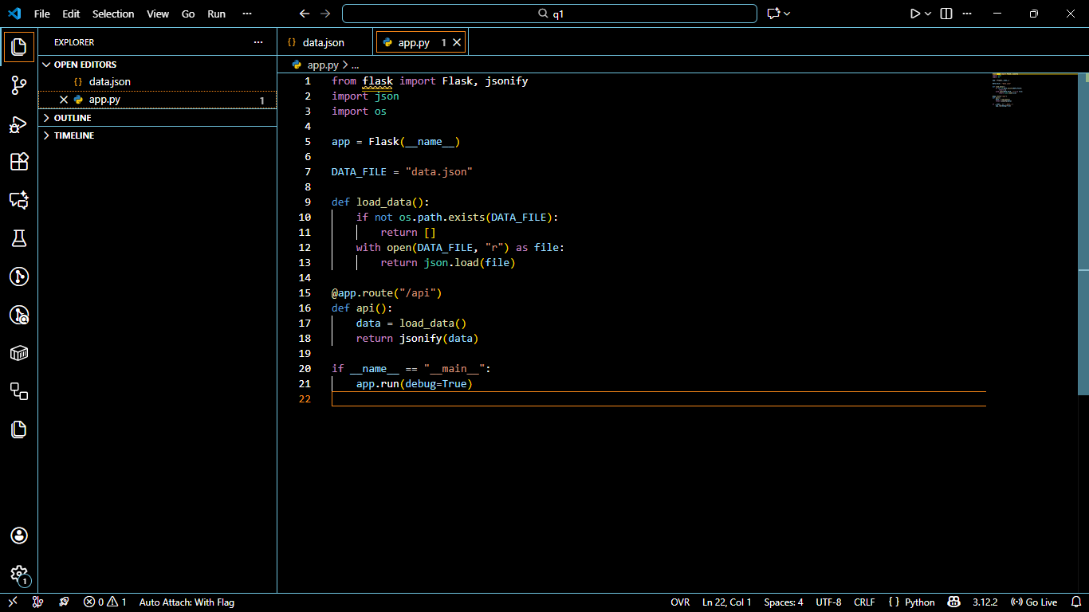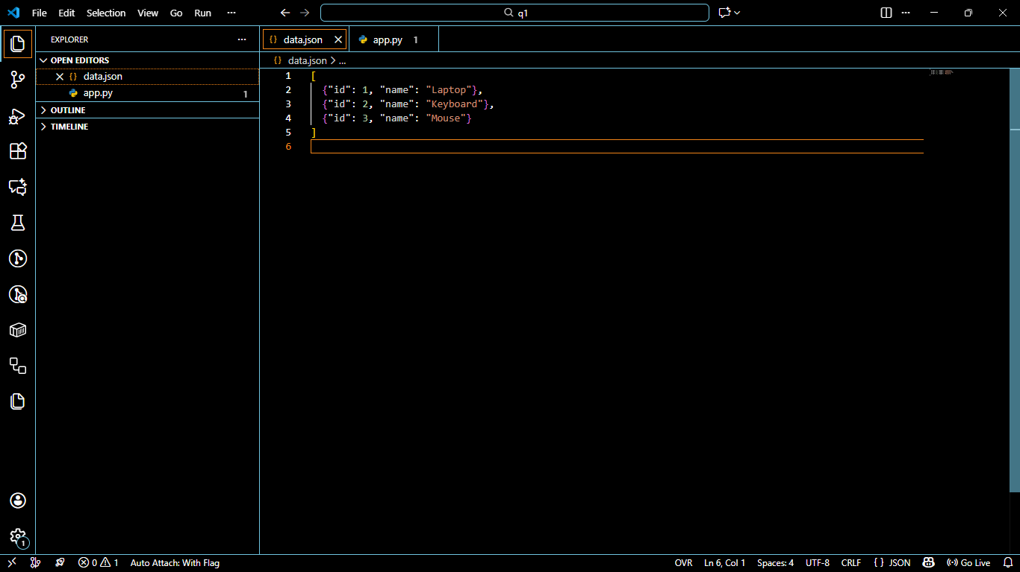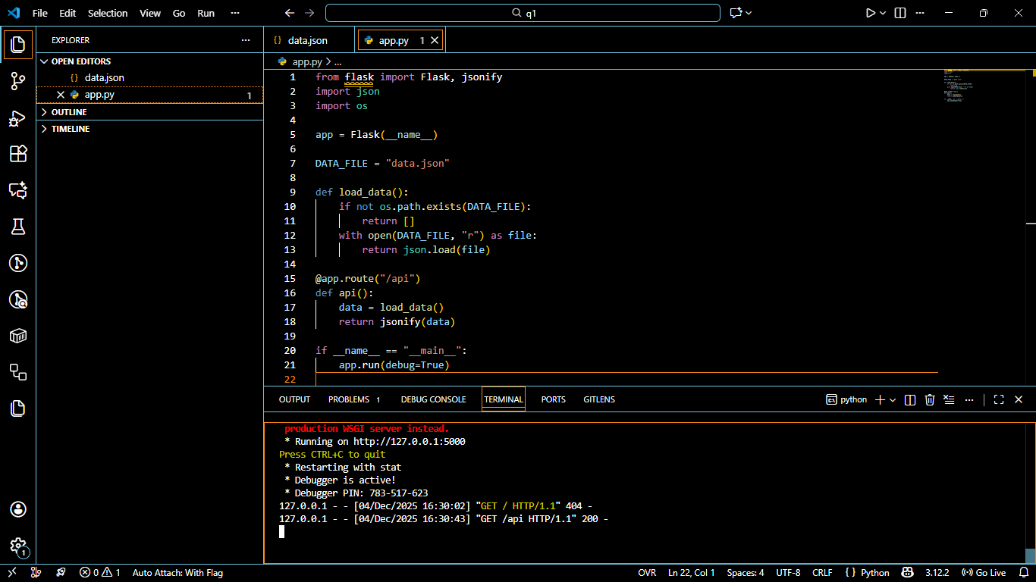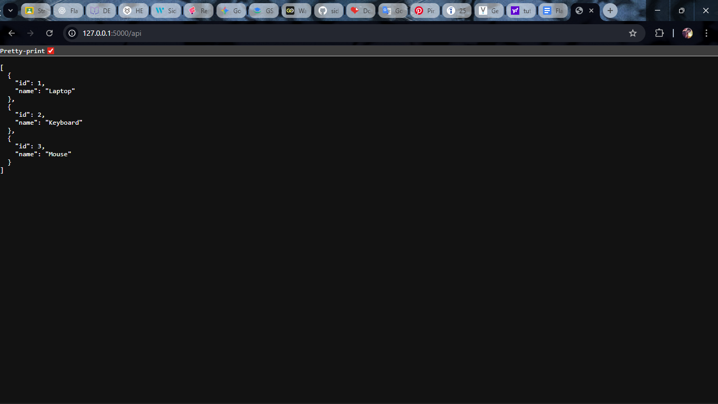

Explanation
This Flask application reads data from a backend file (data.json) and returns it as a JSON list when the /api route is accessed. The app loads the file using Python’s json module and sends the data back using Flask’s jsonify() function. When the Flask server runs and the user opens http://127.0.0.1:5000/api, the items stored in data.json (Laptop, Keyboard, Mouse) are displayed as a proper JSON response. This completes the requirement of serving file-based data through a Flask API.

- Create a form on the frontend that, when submitted, inserts data into MongoDB Atlas. Upon successful submission, the user should be redirected to another page displaying the message "Data submitted successfully". If there's an error during submission, display the error on the same page without redirection. 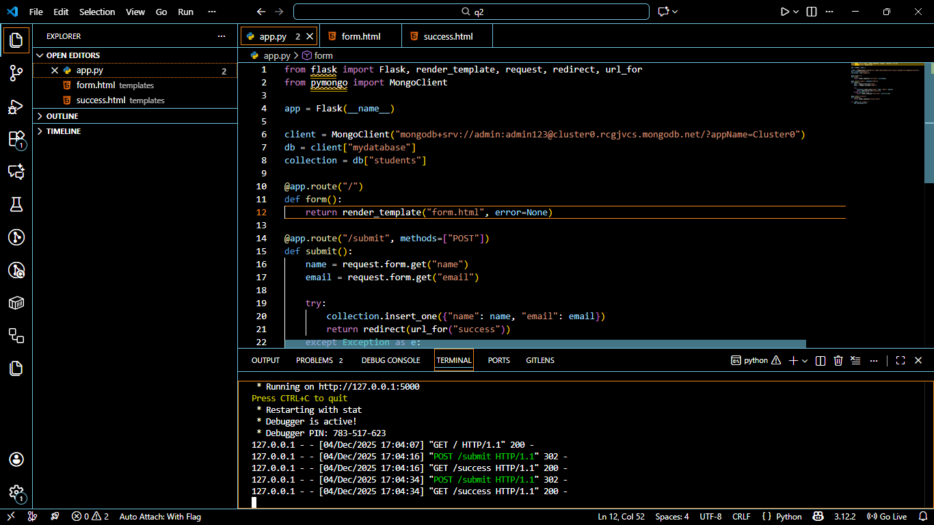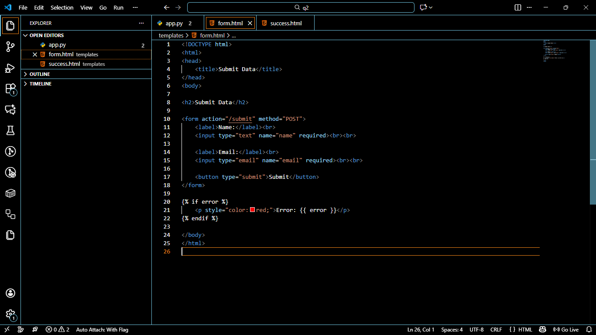
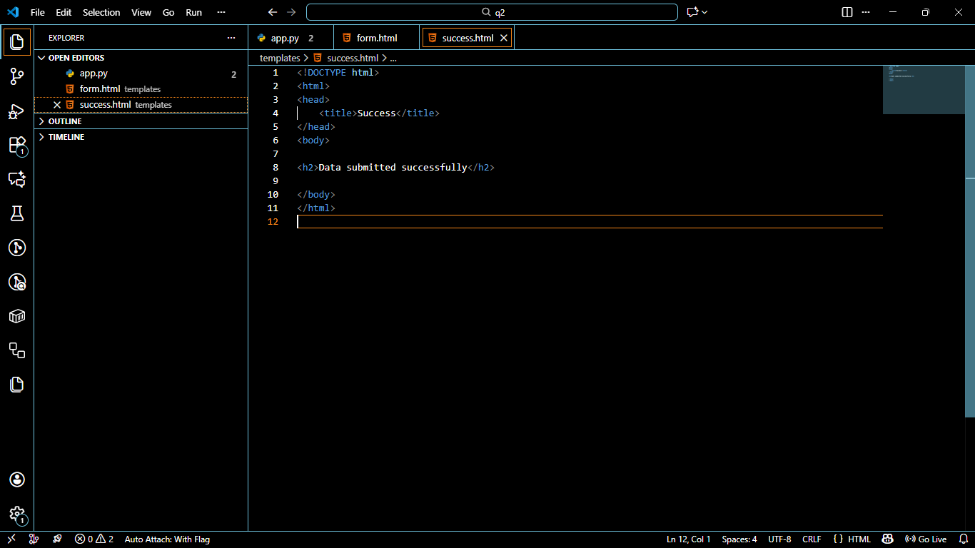
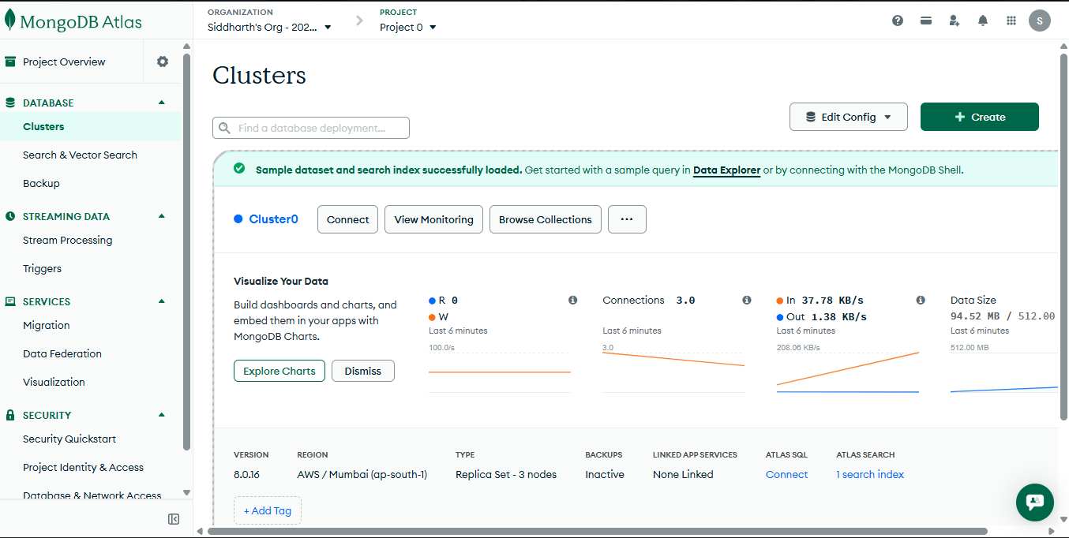
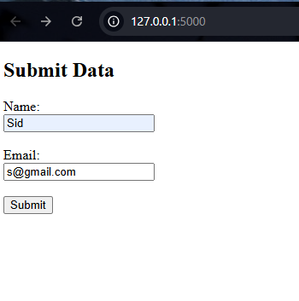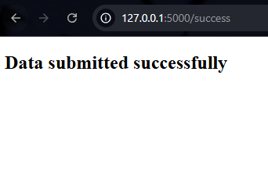
Explanation:
A frontend form was created using HTML and connected to a Flask backend. When the user submits the form, Flask receives the input data and inserts it into a MongoDB Atlas database using the pymongo library. If the data is inserted successfully, the user is redirected to a new page that displays the message “Data submitted successfully”. If an error occurs during database insertion, the same form page is reloaded and the error message is displayed without redirecting. This fulfills the requirement of form submission with success redirection and error handling.

